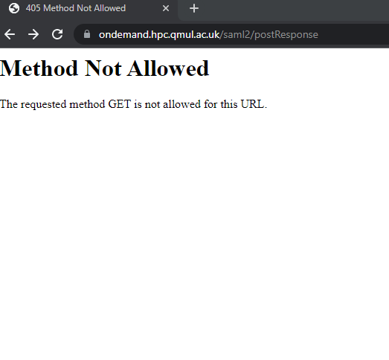

QUAL INFO

83.35 39

110.76 41

80.45 45

109.3 32

n 1

83.35 39